# **CS 1CS 1102-01 - AY2024-T5: Programming Assignment Unit 1**

Godknows Egi

Bachelor of Science in Computer Science, Uopeople

CS 1102-01 - AY2024-T5: Introduction to Java Programming

Rupali Memane

June 27, 2024 ,

**Question 1**

You are tasked with creating a Java program that simulates a simple quiz game. The program should prompt the user with a series of questions and allow them to enter their answers. After the user has answered all the questions, the program should compute and display the final score based on the number of correct answers.

For this assignment, write a Java program that implements the functionality described in the scenario. Ensure that your program is error-free, compiles successfully, and produces the expected output. Test your program with different inputs to verify its correctness.

Make sure the following requirements are met:

* The program should include five multiple-choice questions with four options.
* The four options should be labeled A, B, C, and D.
* The program should prompt the user to enter their answer by typing the corresponding letter (A, B, C, or D).
* After the user has entered their answer for each question, the program should compare it to the correct answer and keep track of the number of correct responses.
* The program should compute and display the final score as a percentage of the total number of questions.
* Use if and switch case statements to handle user input and compare it to the correct answers.
* Include comments to explain the purpose of each section of code and enhance code readability.

**Answer to question 1**

**1. Imports:**

import textio.TextIO;: This line imports the TextIO class from the textio package as shown from the example on the textbook Eck, D. J. (2022). **Introduction to programming using java version 9, JavaFX edition ,*Chapter 2.4 Text Input and Output (pp 41)*** . This package is not part of the standard Java libraries and needs to be included separately. It provides methods like getChar() to get user input from the terminal, this package extends the System input subroutine.

**2. Class Definition:**

public class Uopeople_Unit1_assignment : This is the name of my class where the main function is been written

**3. Options Enum:**

enum Options { ... }: This defines an enum type named Options. Enums are a way to represent a fixed set of named constants. In this case, the enum represents the different answer choices (A, B, C, D) for each question.

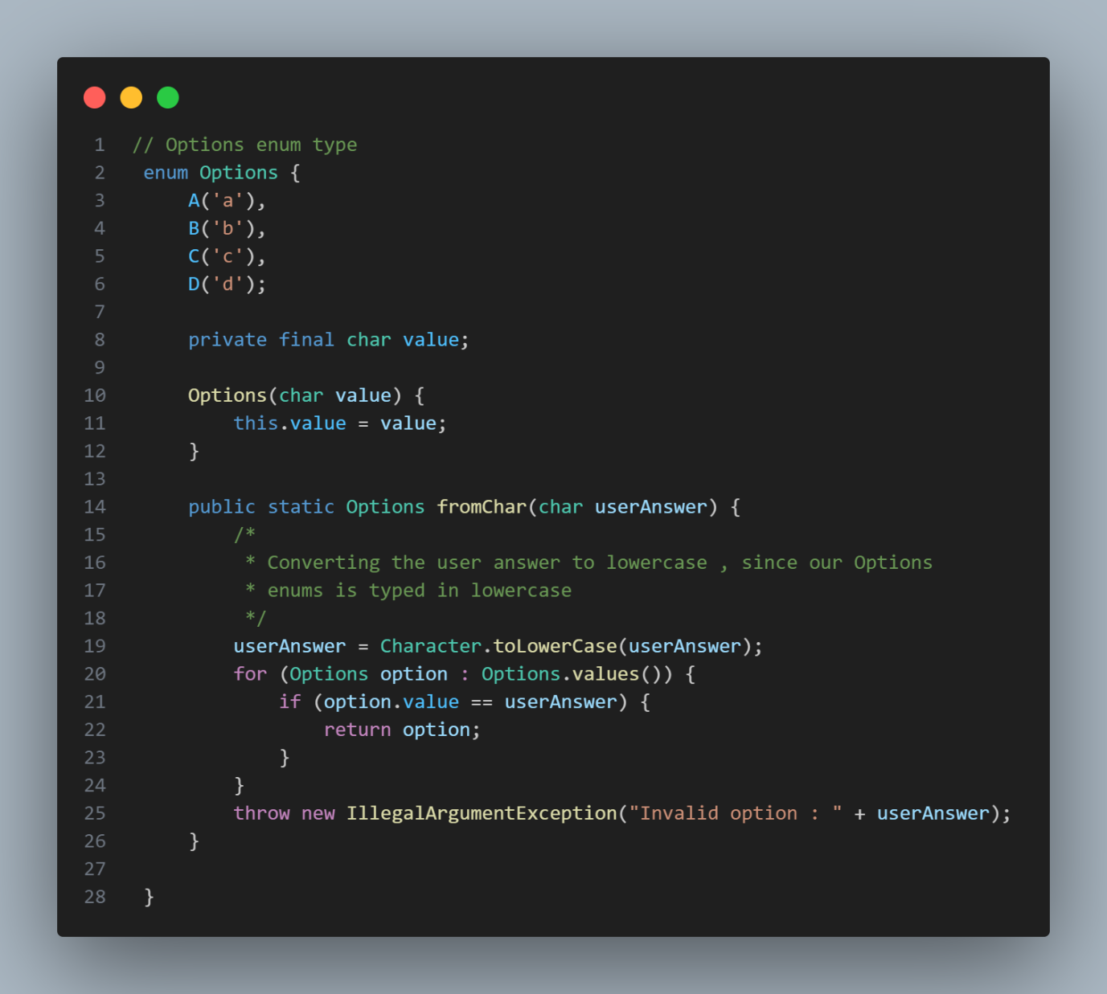

***Options enum Fig. 1***

The enum has a subroutine called fromChar which takes the user answer for a given question converts it to a lowercase string for comparing to the options enum, it also handle exceptions where user answer doesn’t match any given option.

**4. Questions:**

The program defines five string variables (question1 to question5) using the java text blocks (introduced in Java 17) as stated on the textbook Eck, D. J. (2022). **Introduction to programming using java version 9, JavaFX edition ,*Chapter 2.3.4 Text Blocks: Multiline Strings (pp 36)***. These strings contain the question text and answer choices.

**5. Correct Answers:**

Five Options variables (answerToQuestion1 to answerToQuestion5) store the correct answer choices for each question.

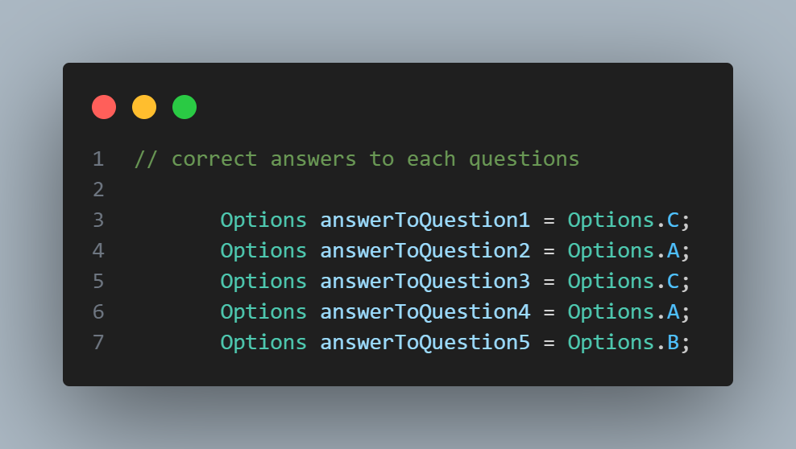

***Correct answers to each questions Fig. 2***

**6. User Input:**

Five Options variables (userAnswerToQuestion1 to userAnswerToQuestion5) are declared to store the user's answers gotten from the Sytem input streams.

A variable userMarks is initialized to 0 to keep track of the user's score.

The program loops through each question, printing the question using System.out.println and then using TextIO.getChar() to get the user's answer as a character. The Options.fromChar method is used to convert the character answer (e.g., 'A') to the corresponding Options enum value.

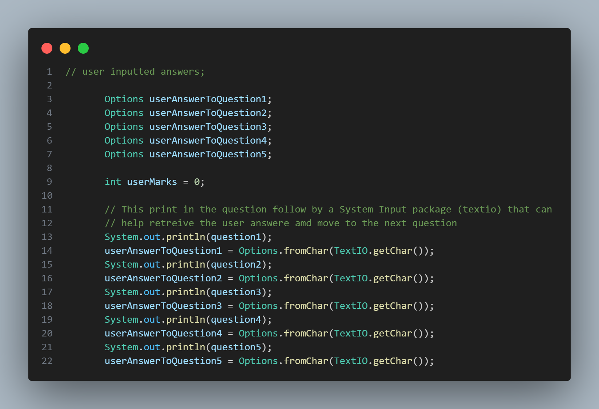

***user answers to each questions and Println questions Fig. 3***

**7. Grading:**

The program uses a series of if statements to check if the user's answer for each question matches the correct answer. If they match, the userMarks variable is incremented by 10.

**9. Result String:**

A long string literal (using text blocks again) is constructed using String.format ( which takes dynamic values) . This string contains the formatted results for each question, showing the user's answer, result (Correct/Failed), and the correct answer. It also displays the final score.

The String.format method uses placeholders (%s) to insert the user's answer and result dynamically based on the comparison with the correct answer.

Lastly the program prints the entire result string to the console using System.out.println.

Overall, this code demonstrates how to create a quiz application in Java. It uses text blocks for cleaner multi-line strings, an enum for answer choices, and conditional statements for grading.

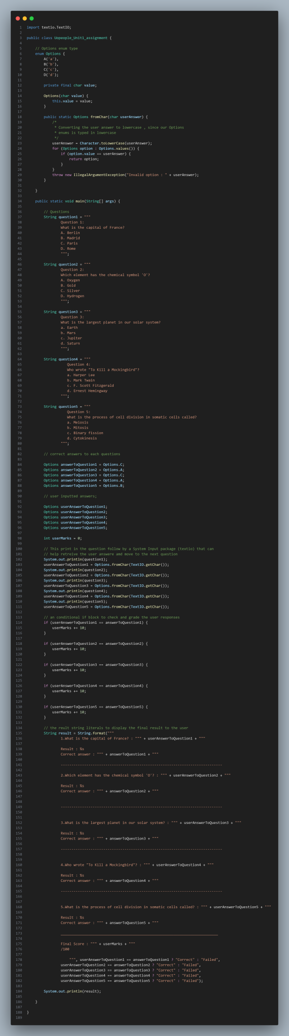

***Entire code file Fig. 4***

**References**

Eck, D. J. (2022). Introduction to programming using java version 9, JavaFX edition ,*Chapter 2.4 Text Input and Output (pp 41)*

Eck, D. J. (2022).Introduction to programming using java version 9, JavaFX edition ,*Chapter 2.3.4 Text Blocks: Multiline*

<https://my.uopeople.edu/pluginfile.php/1861434/mod_page/content/55/Introduction%20to%20Programming%20Using%20Java_Textbook.pdf>